SE – Project
NAME: Joshua Jerome
CLASS: 5D
SRN: PES1UG24CS204
SETUP
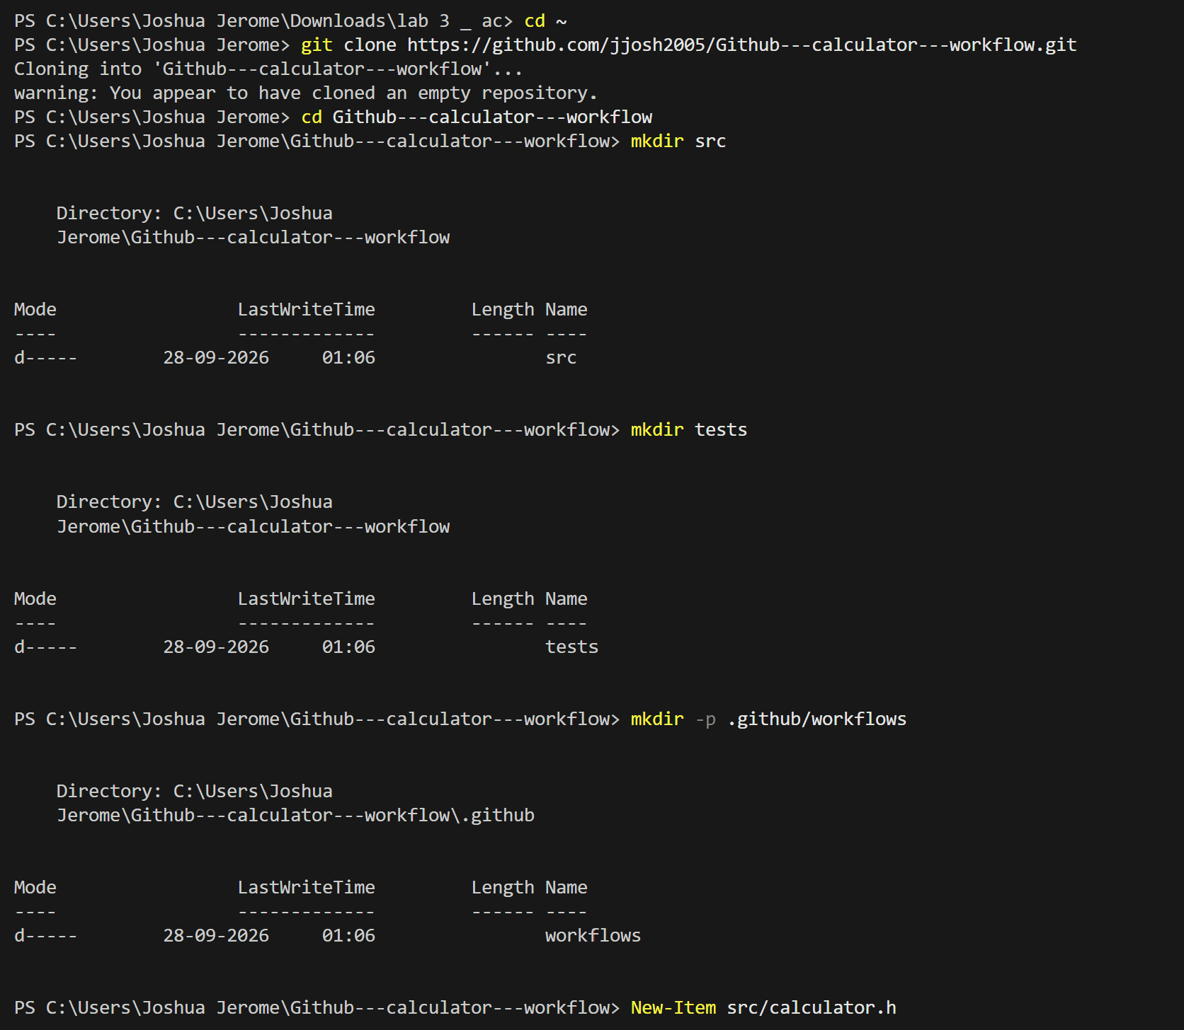

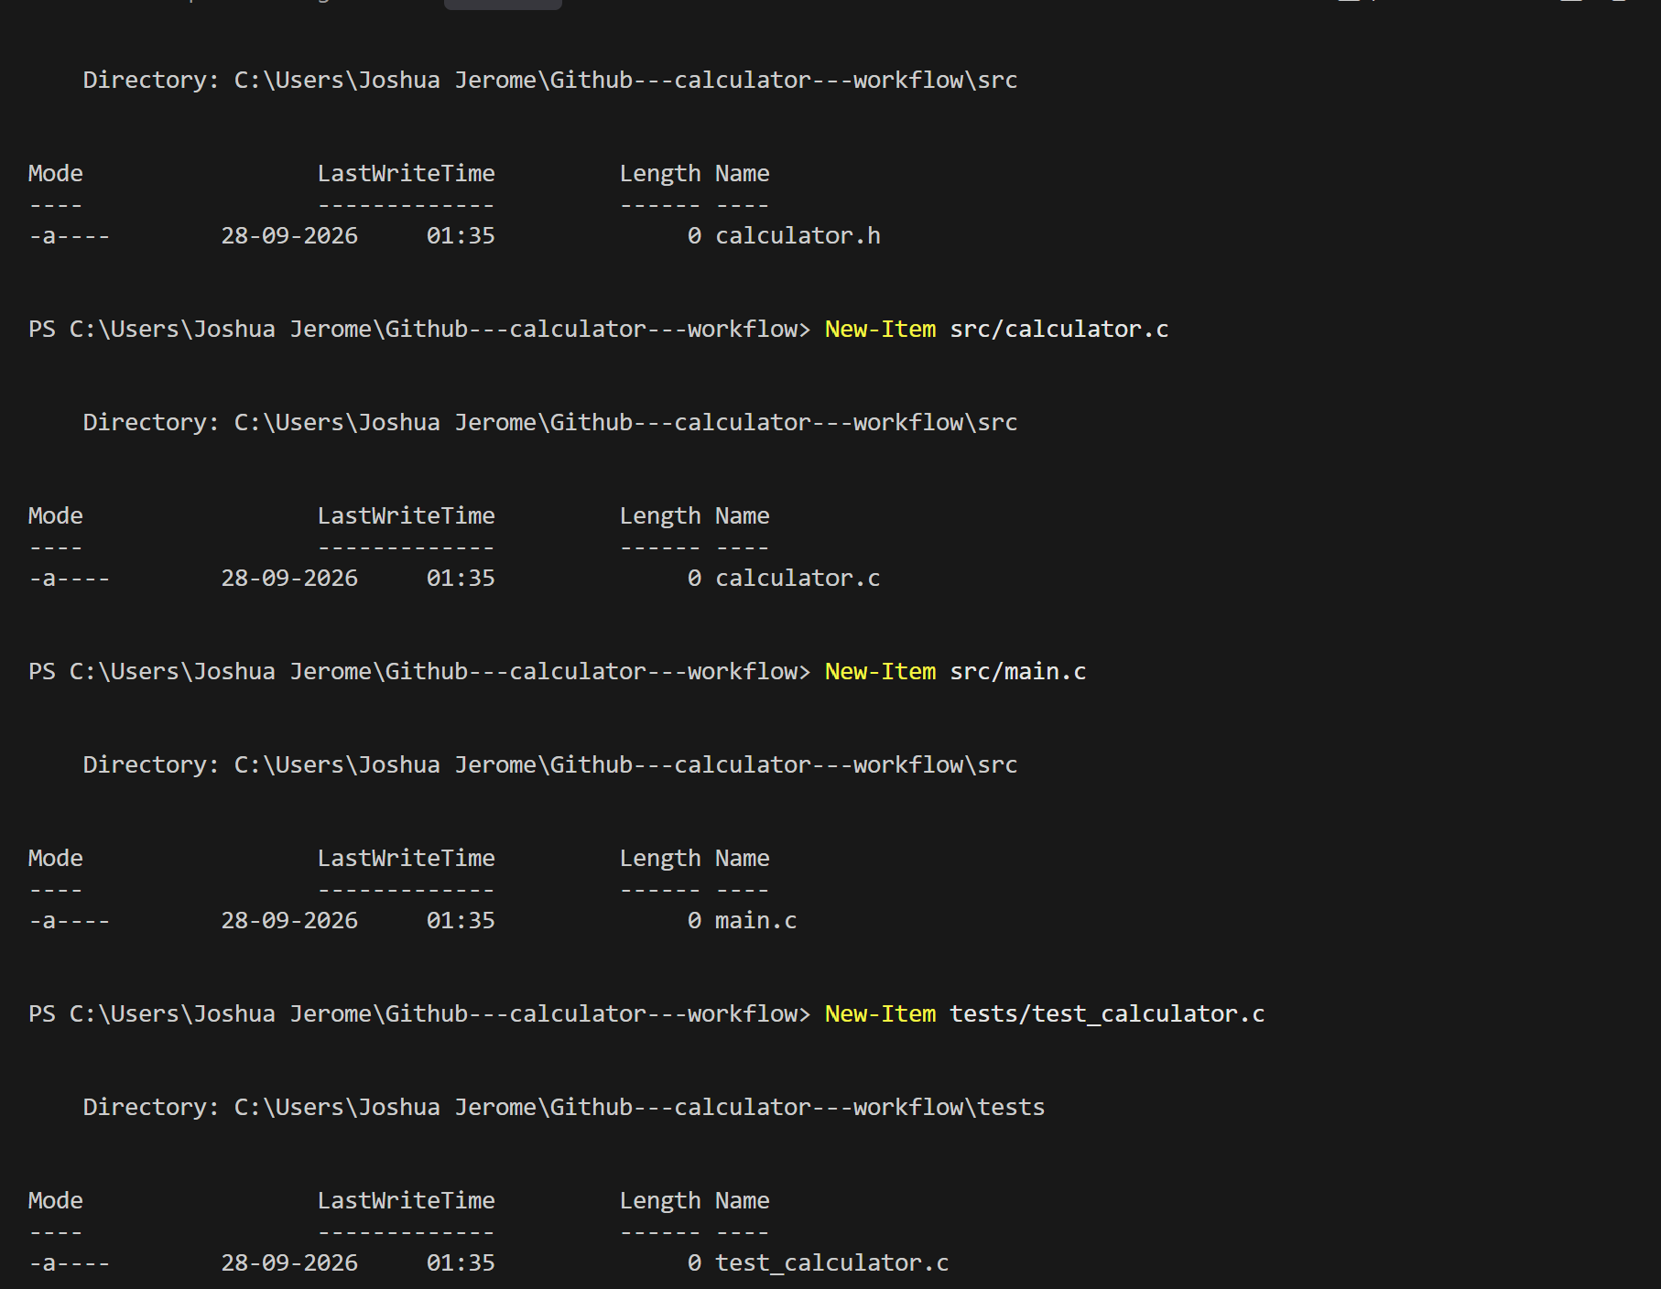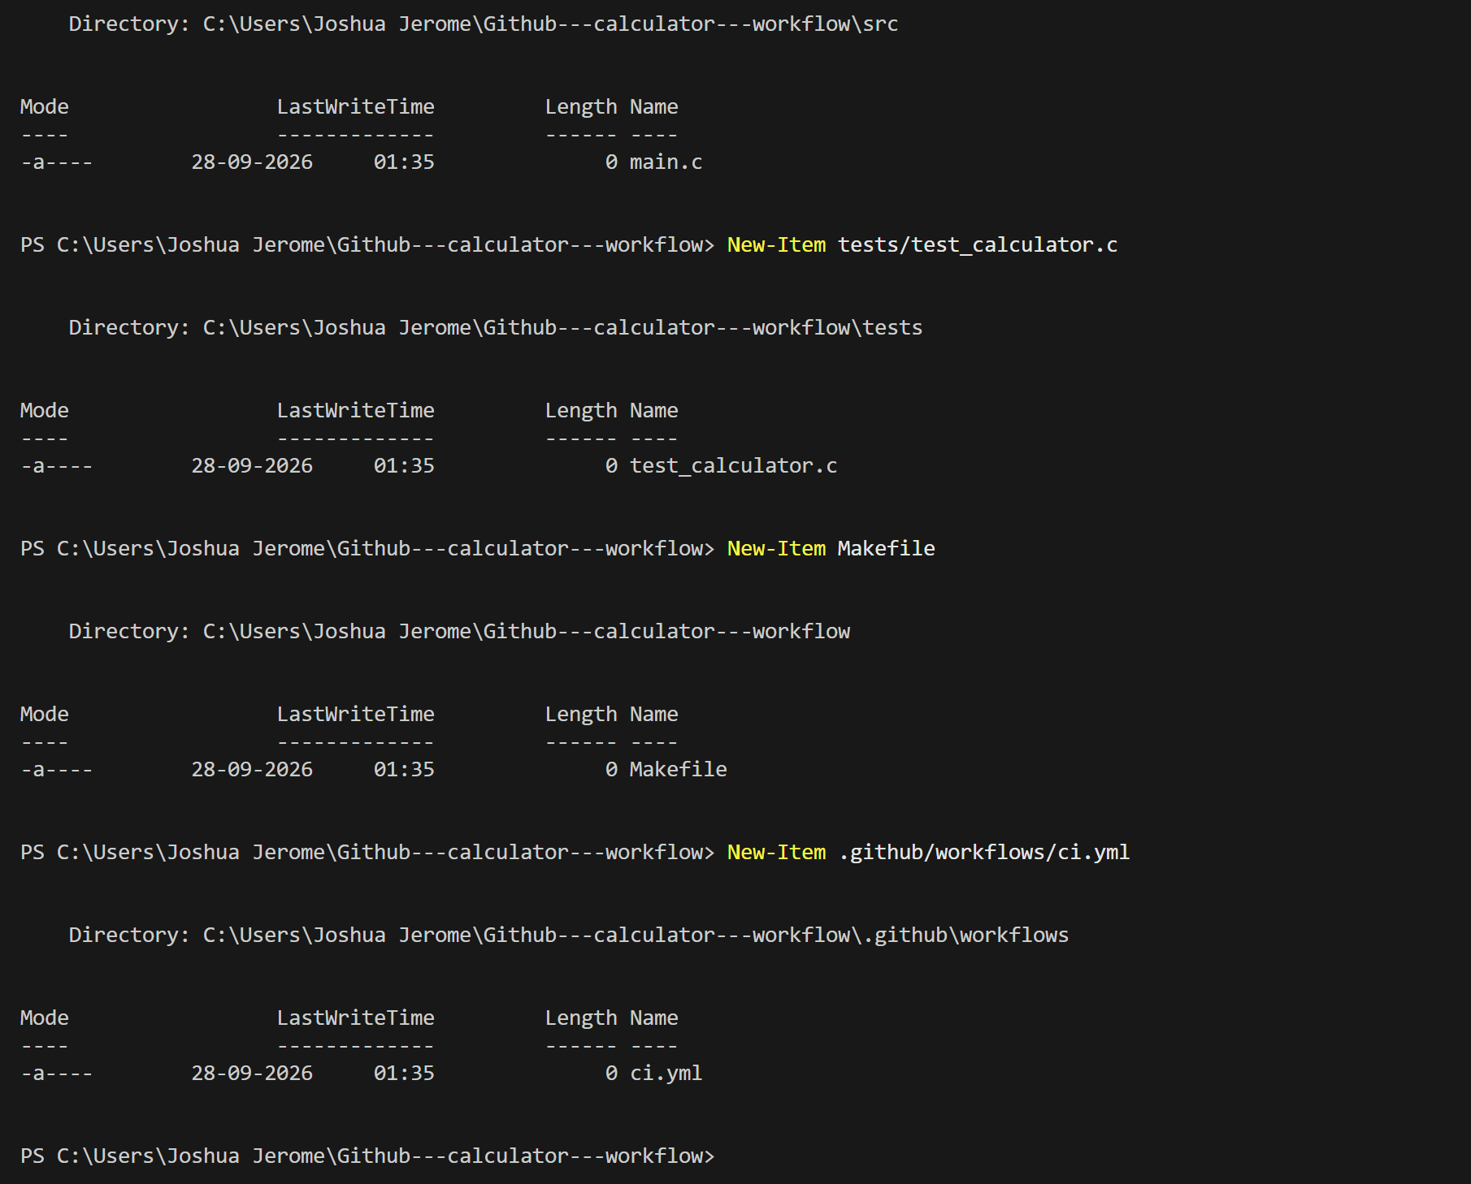
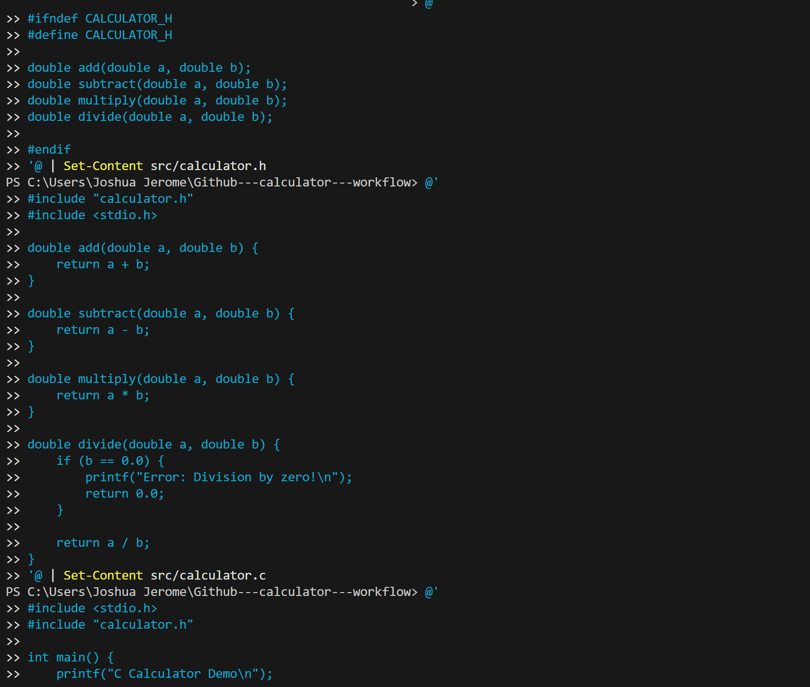
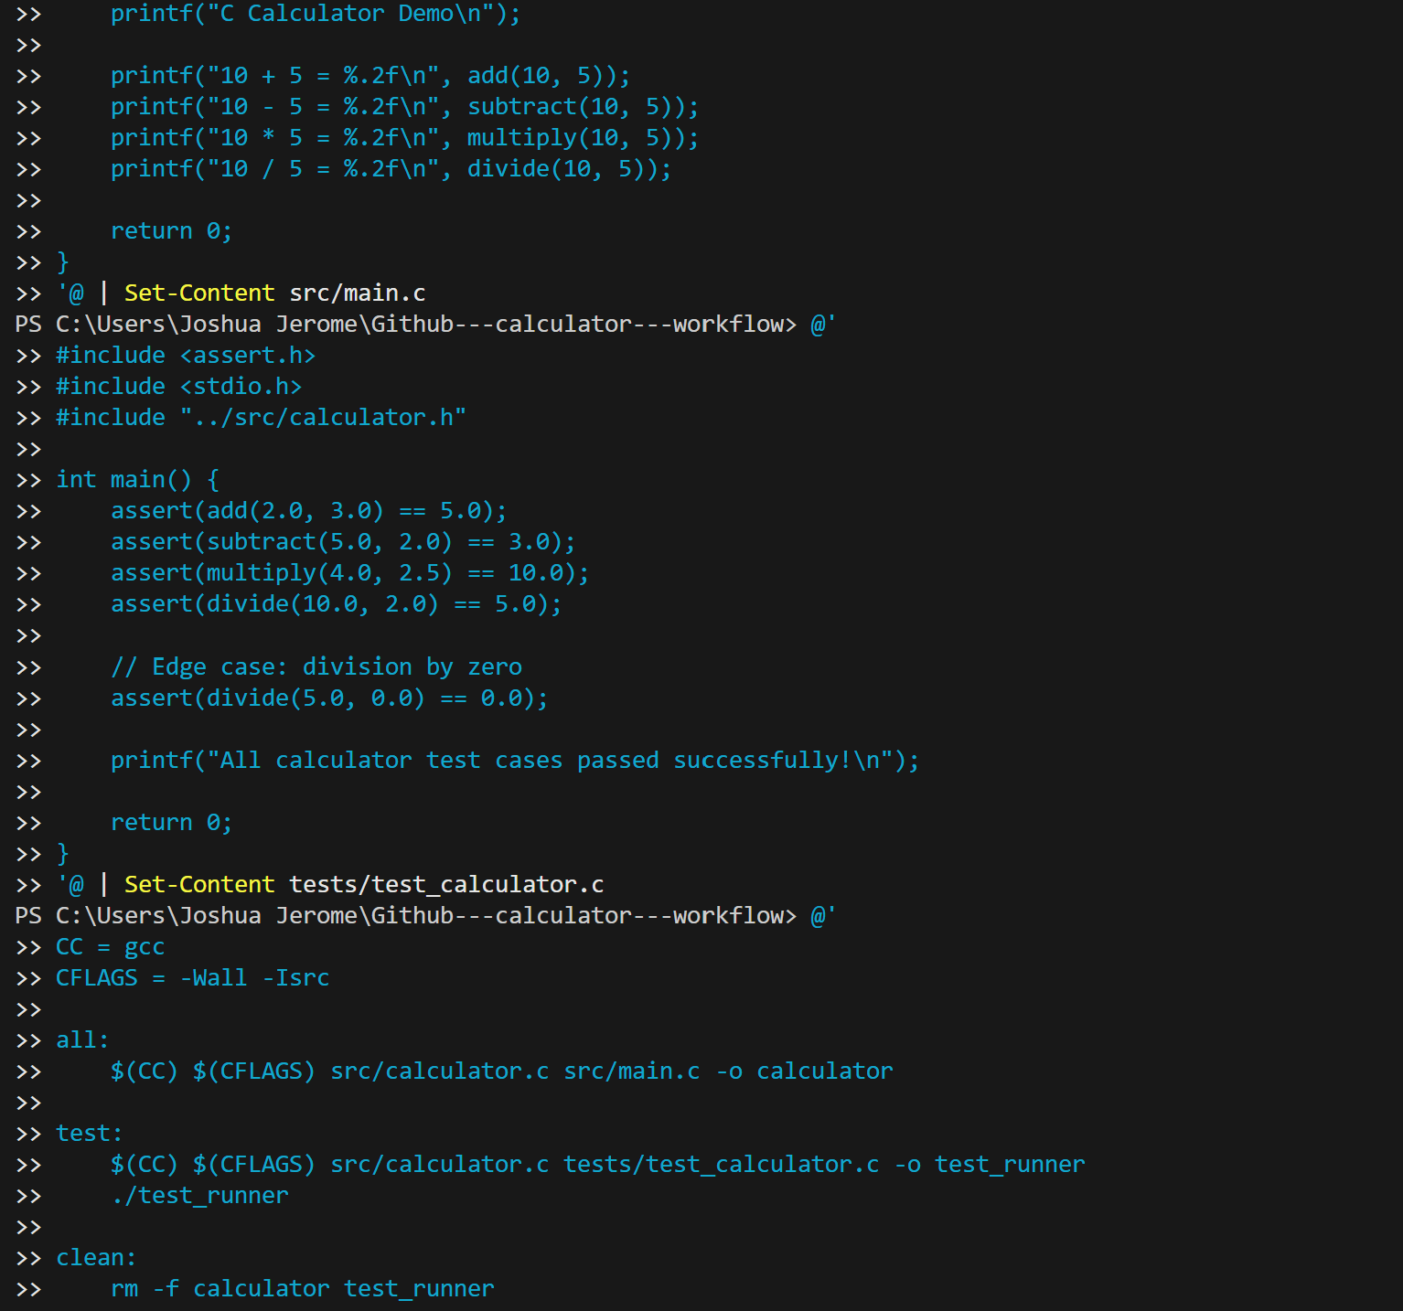
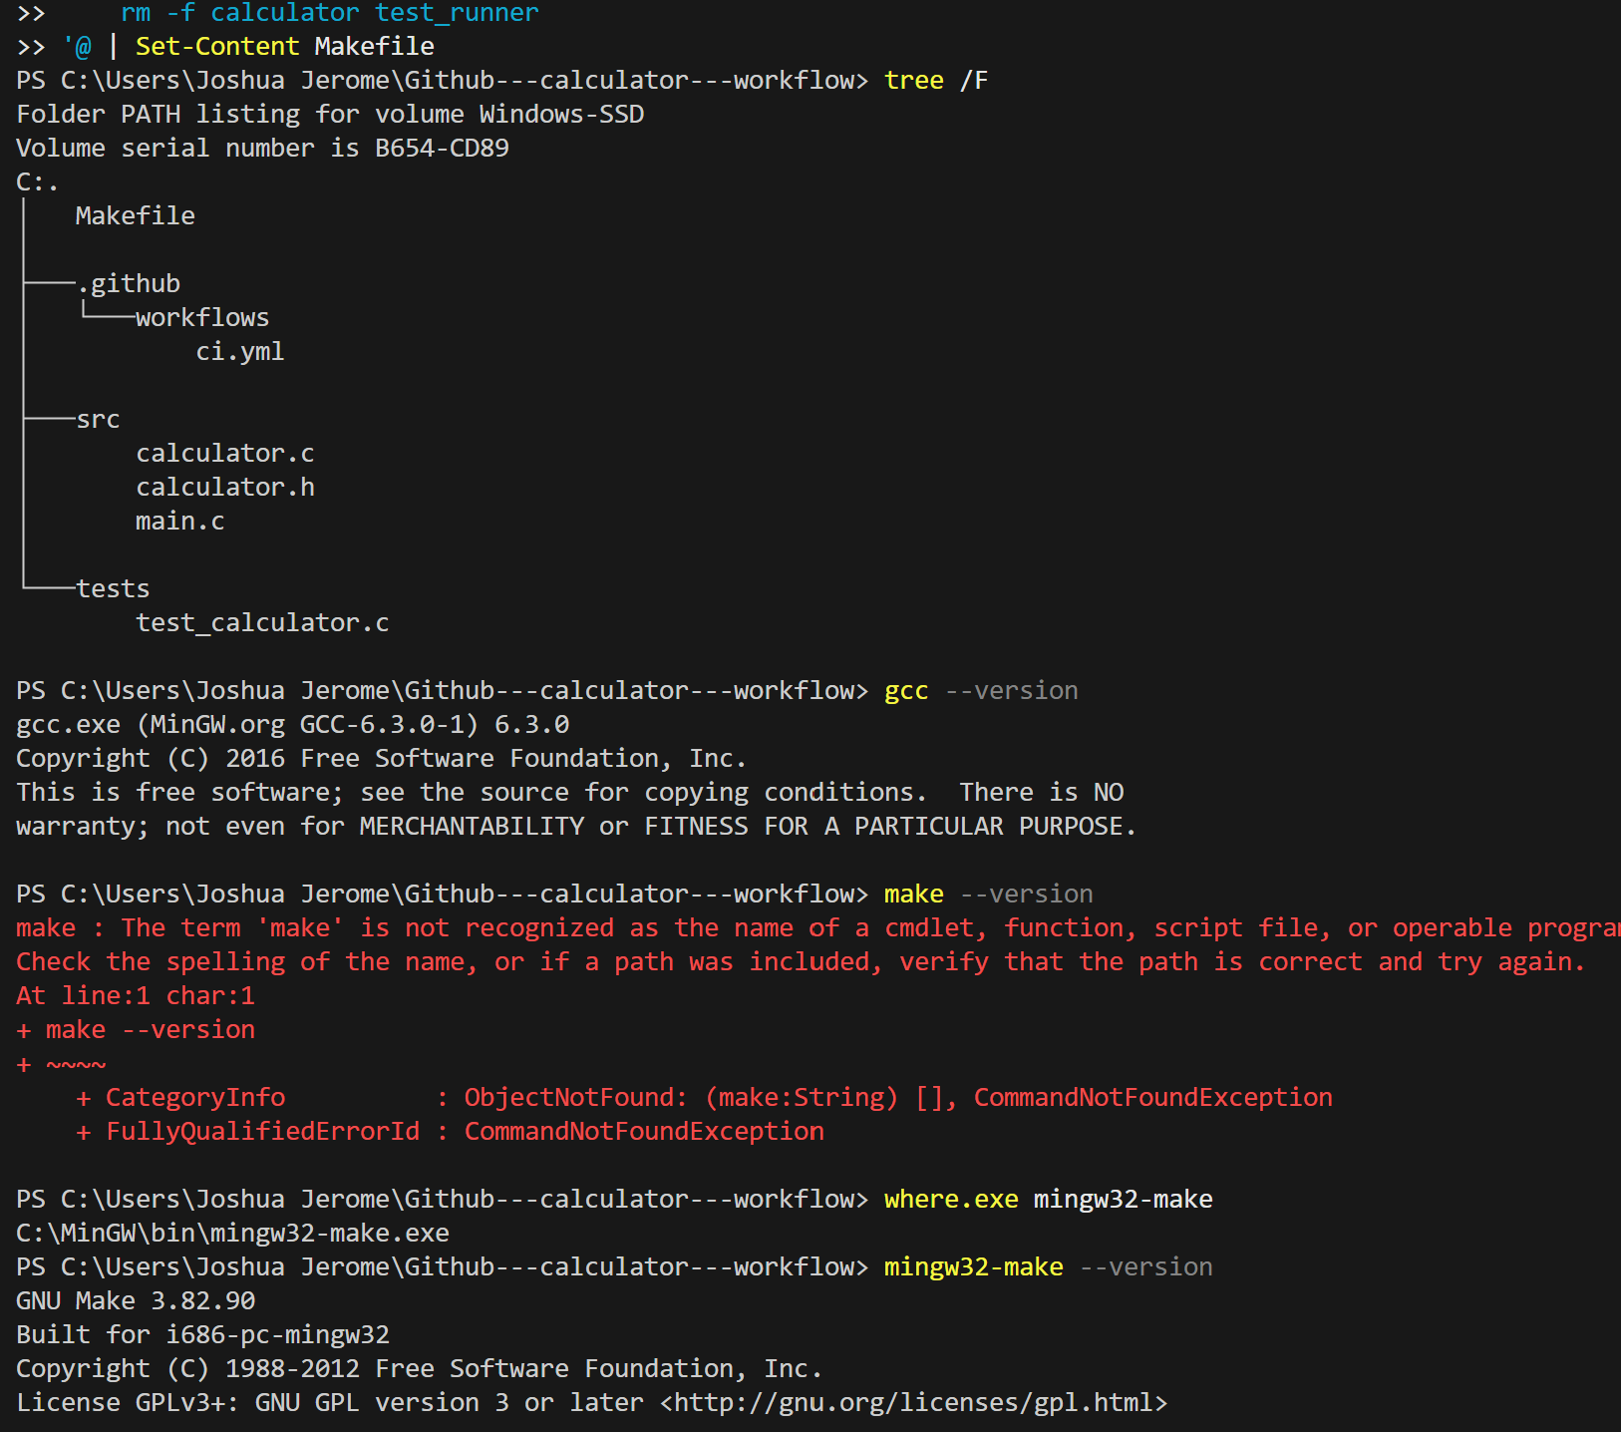
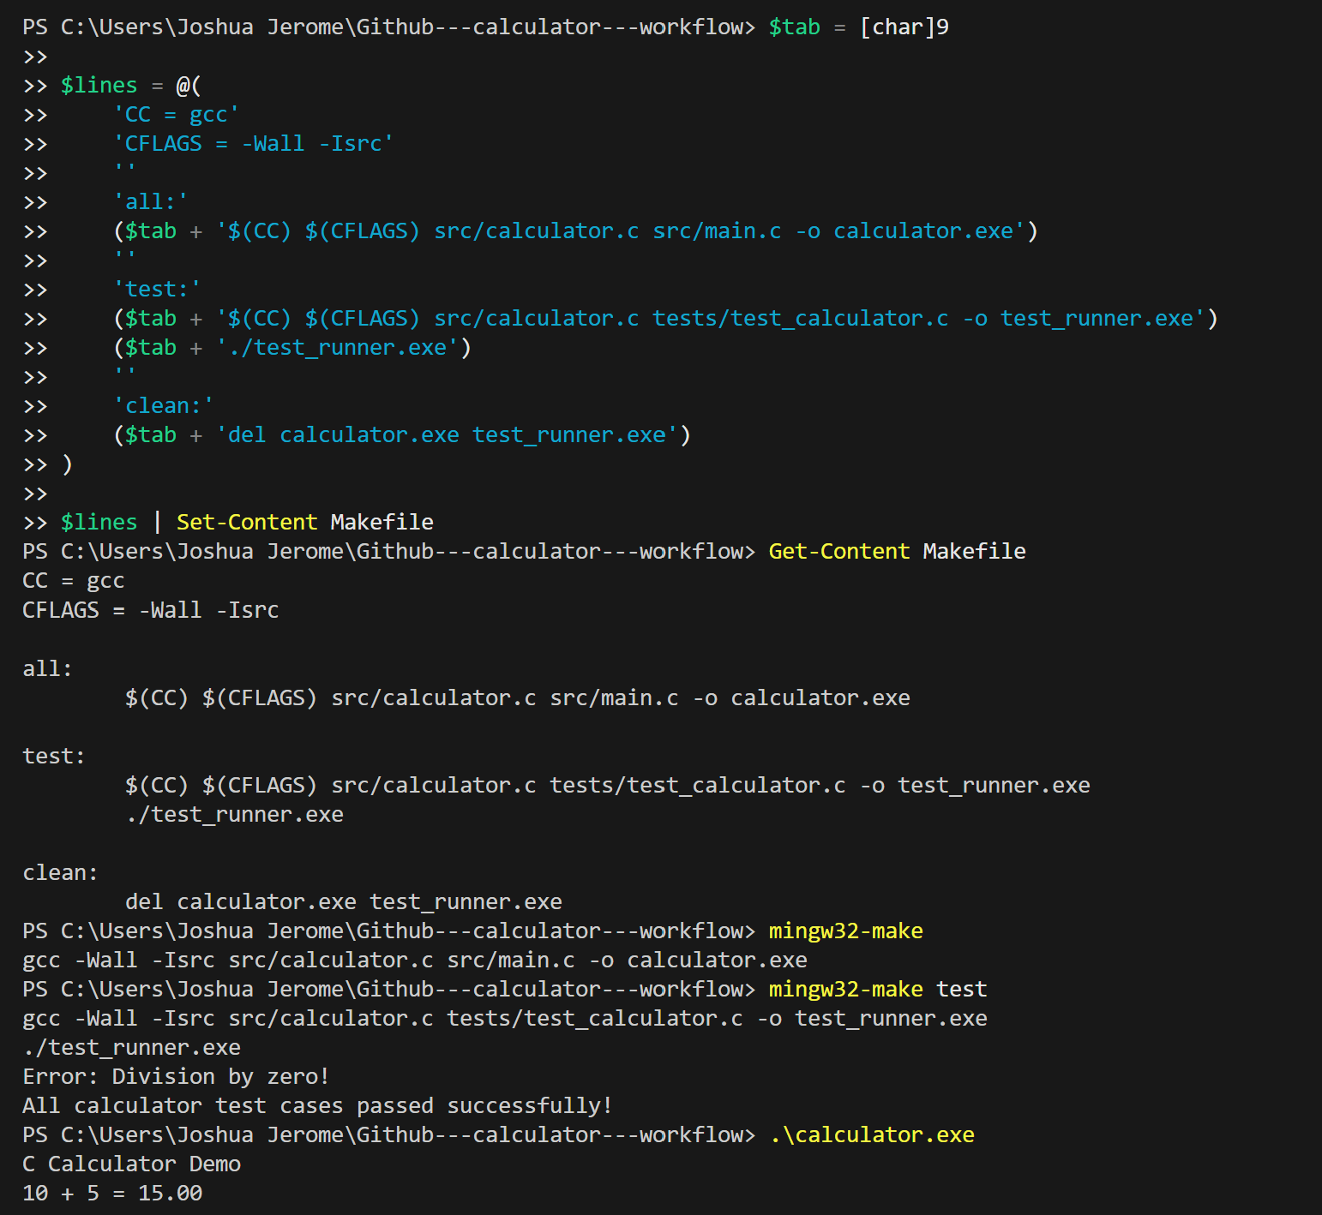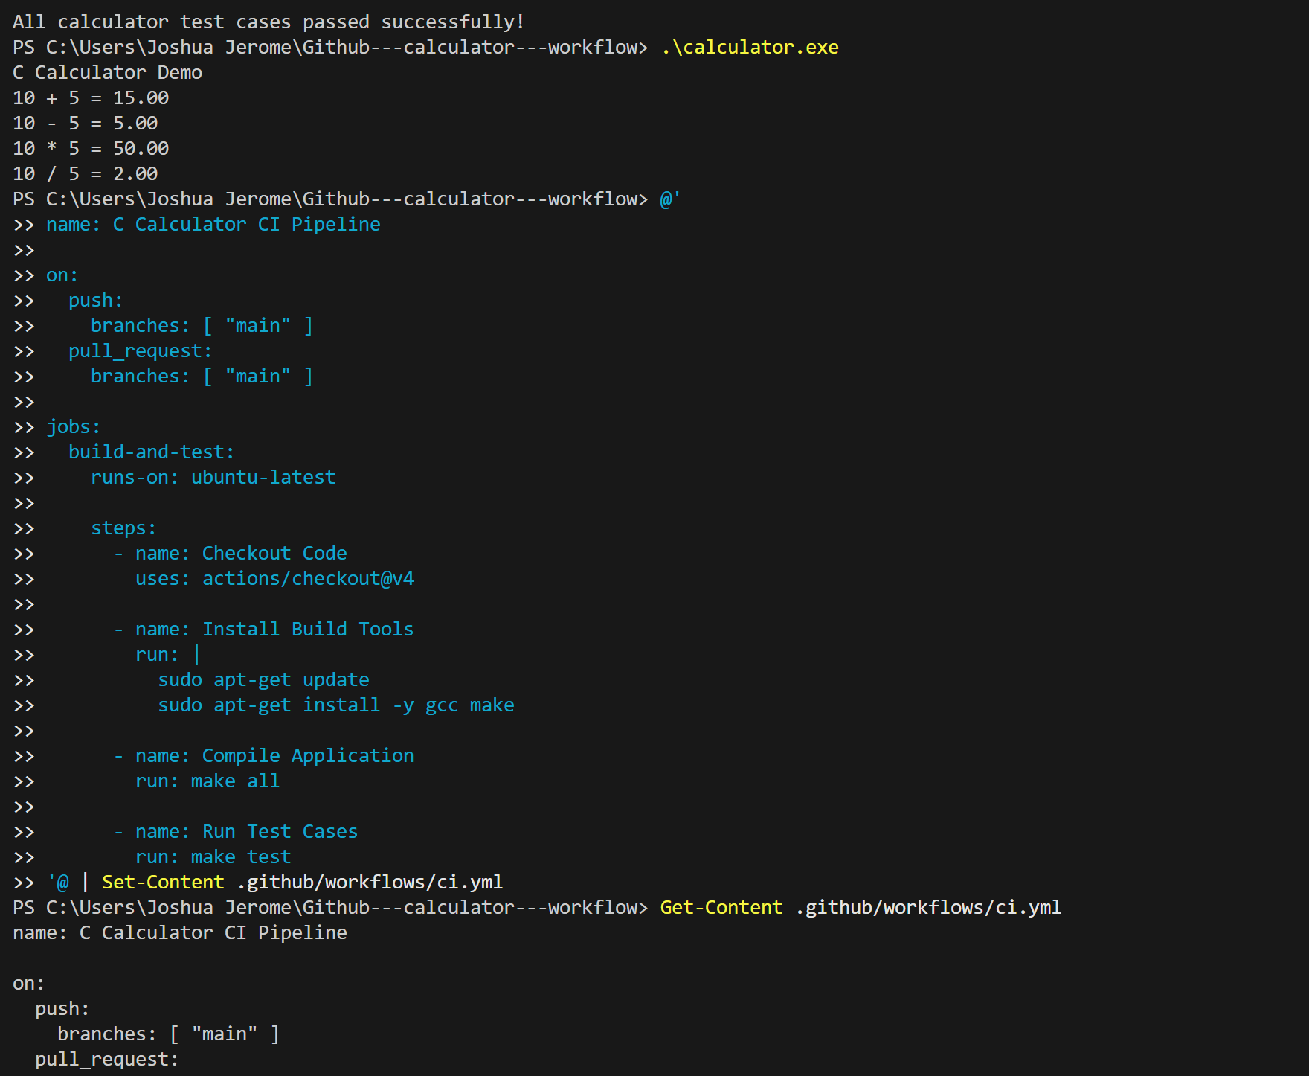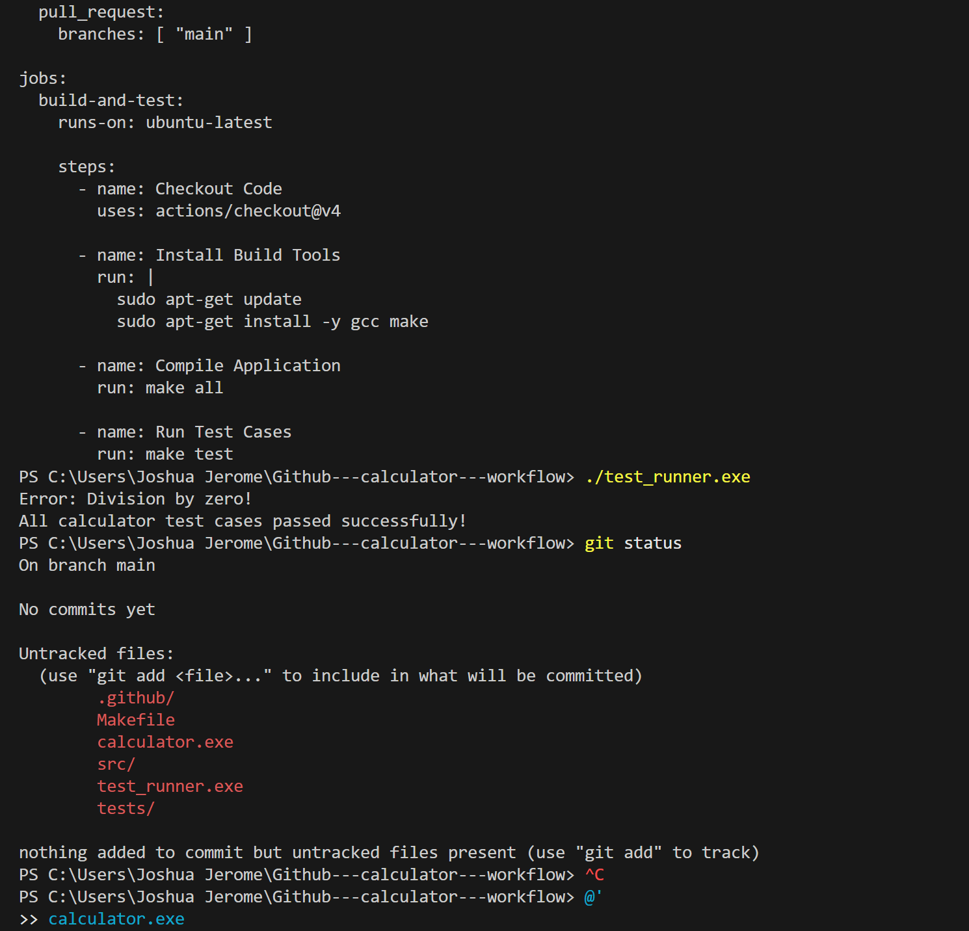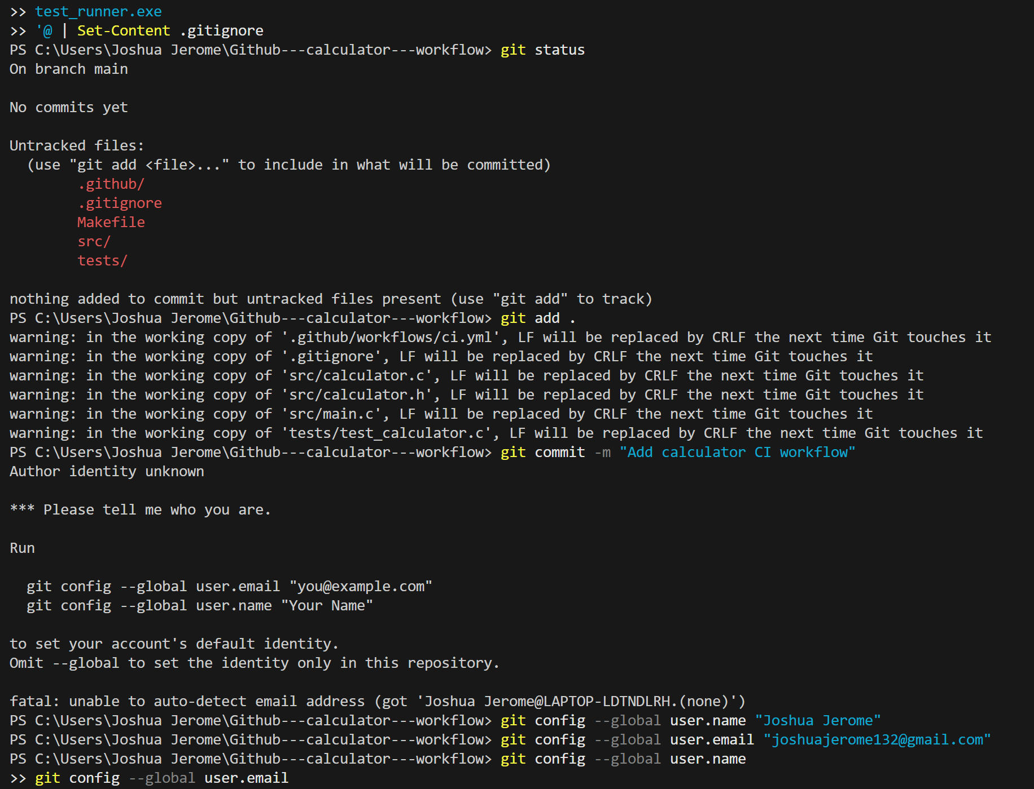
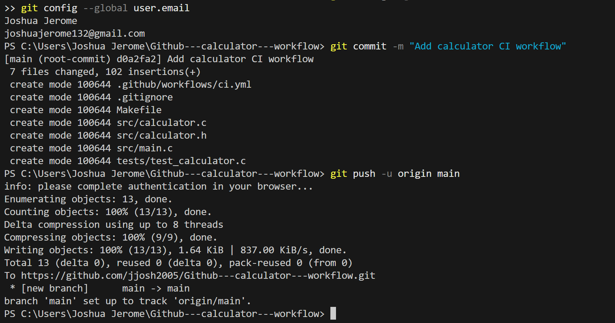
Step 1
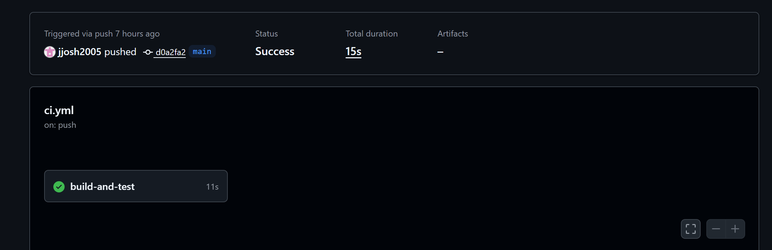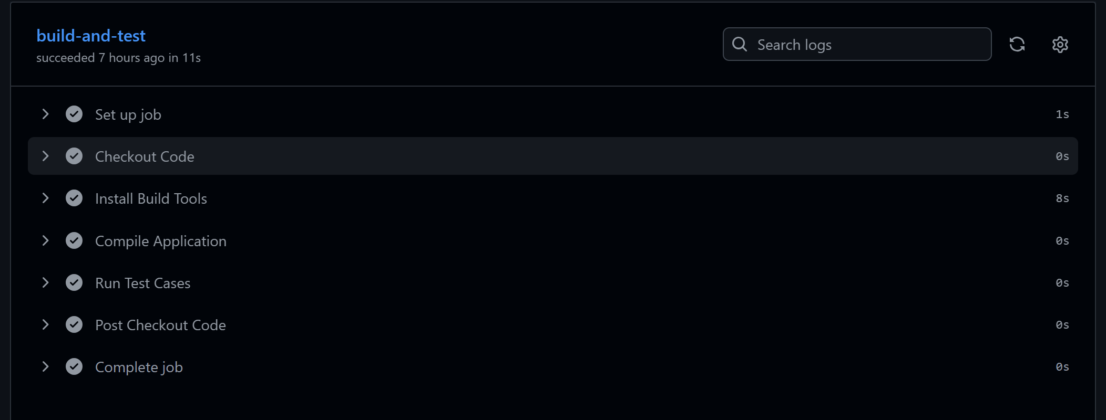
Step 2
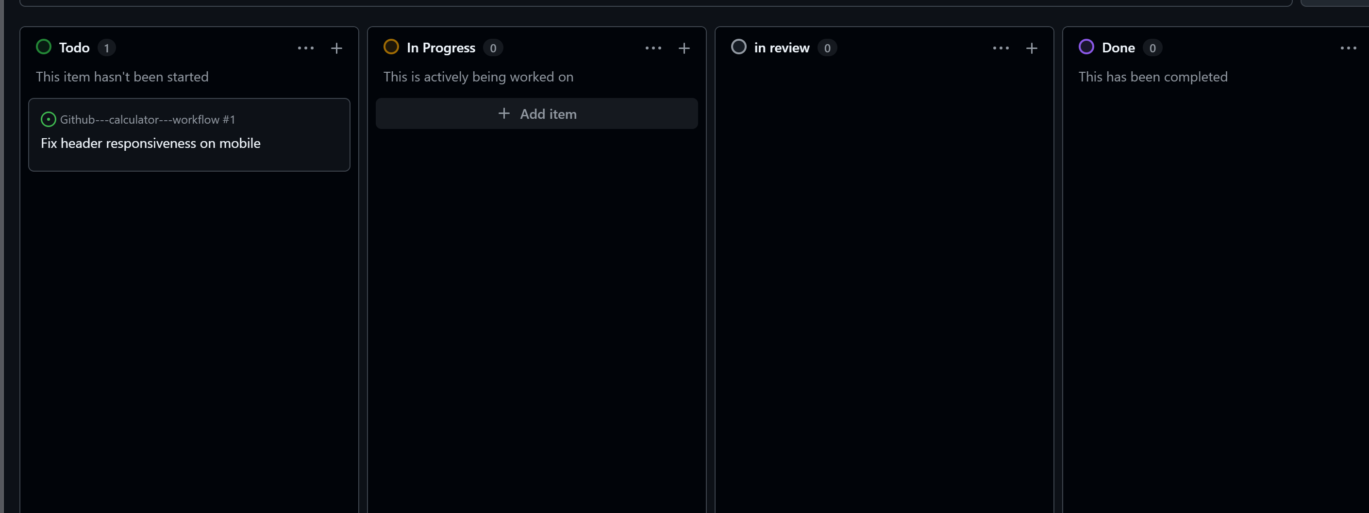
witch to the Projects tab. ○ Observation: Notice how Issue #1 automatically appeared on the board inside the Todo column without any manual dragging
step 3
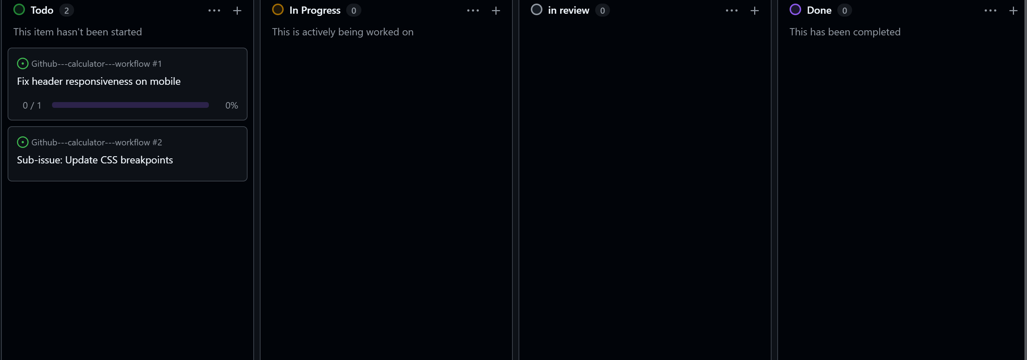
The sub-issue automatically appears on the project board alongside the parent issue.
Step 4
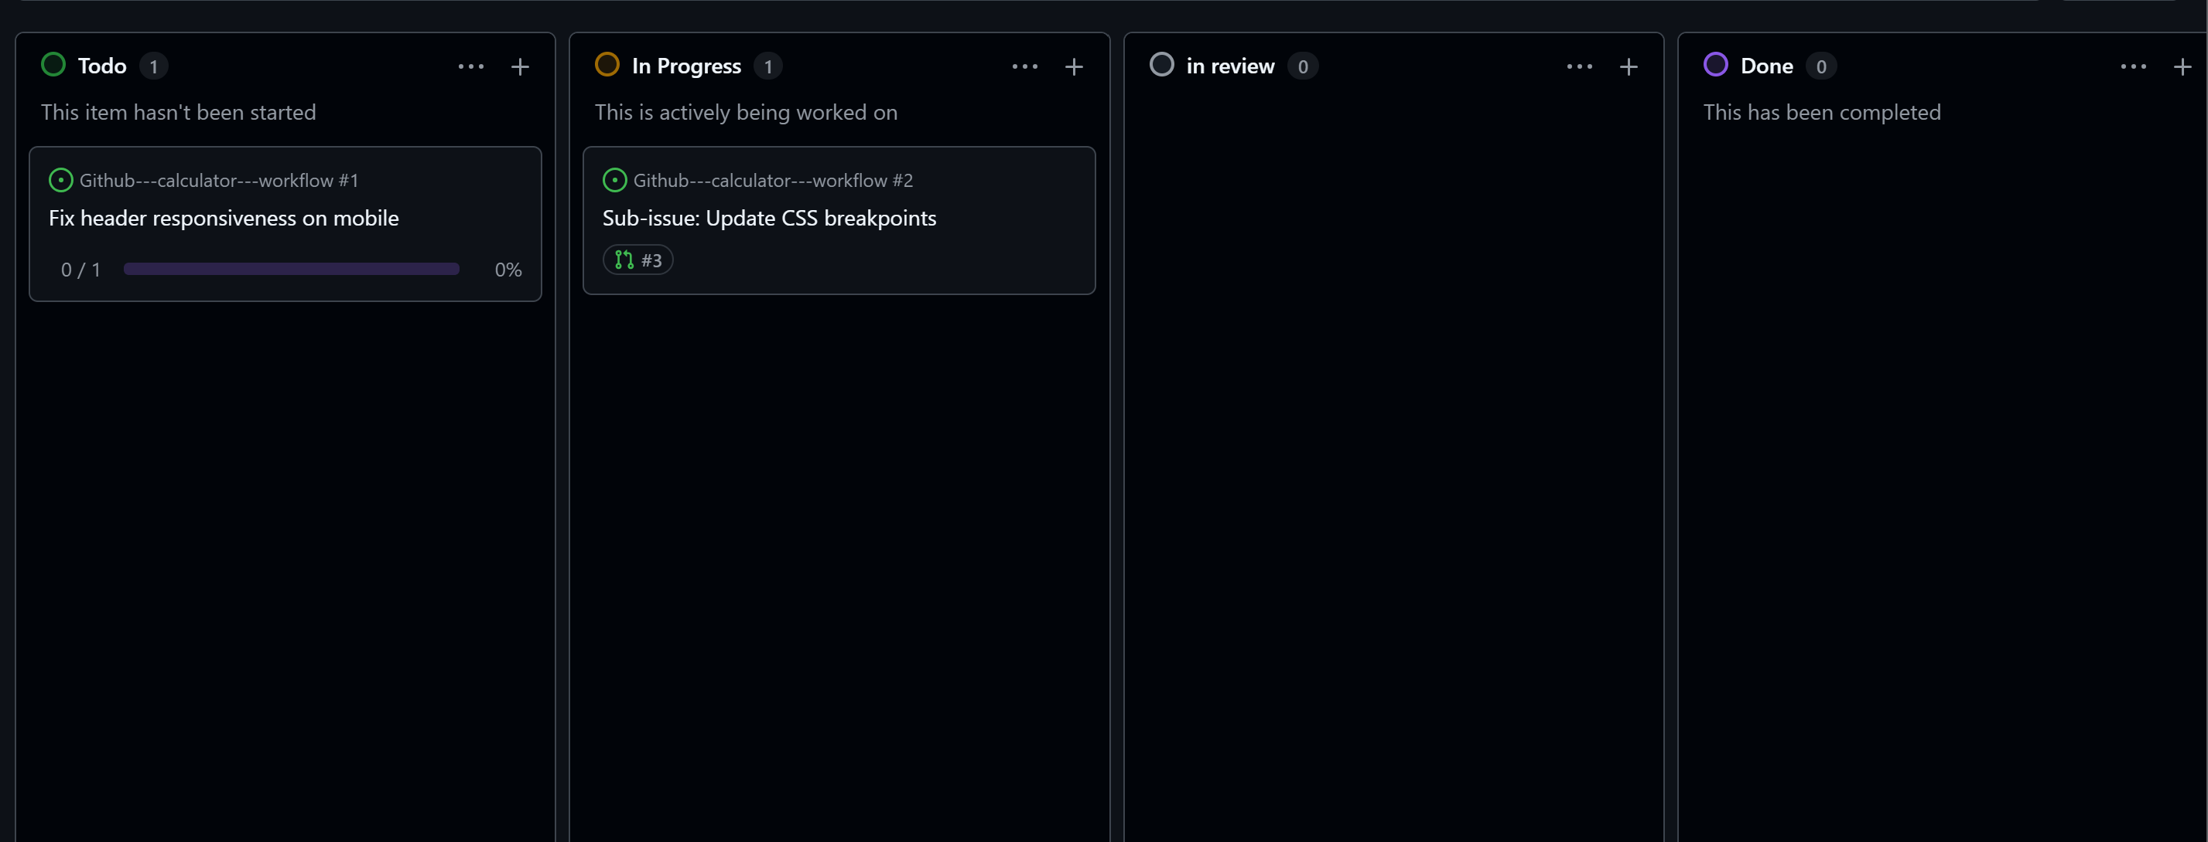
The sub-issue card automatically moved from Todo \rightarrow In Progress as soon as the PR was linked.
Step 5
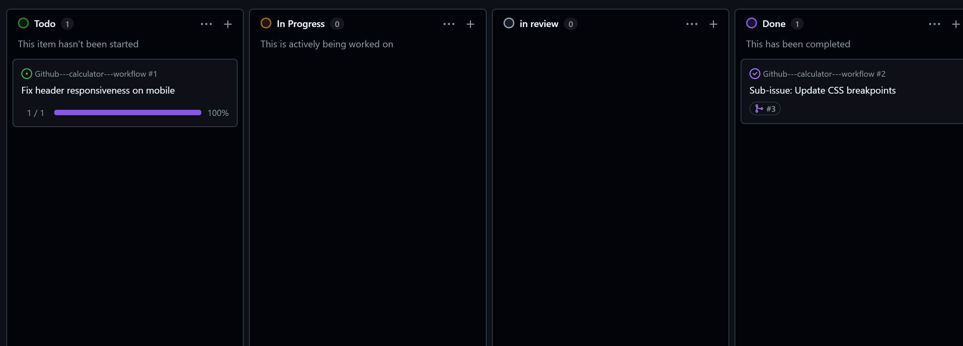
Both the Pull Request and the linked Sub-issue have automatically moved to the Done column.
Step 6
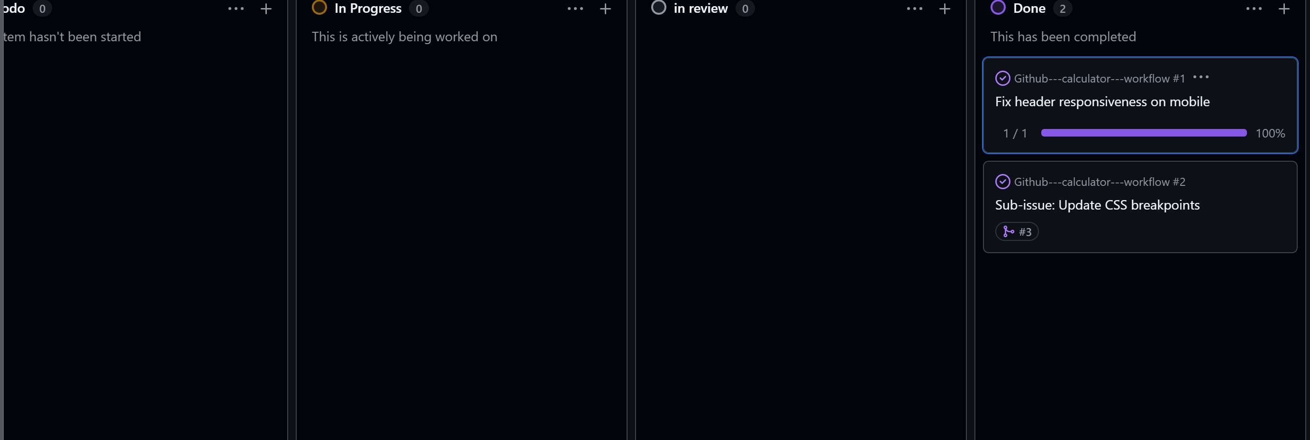
GitHub automatically changed the state of Issue #1 from Open to Closed because it was dropped into Done.

